CATEGORY: SKIN

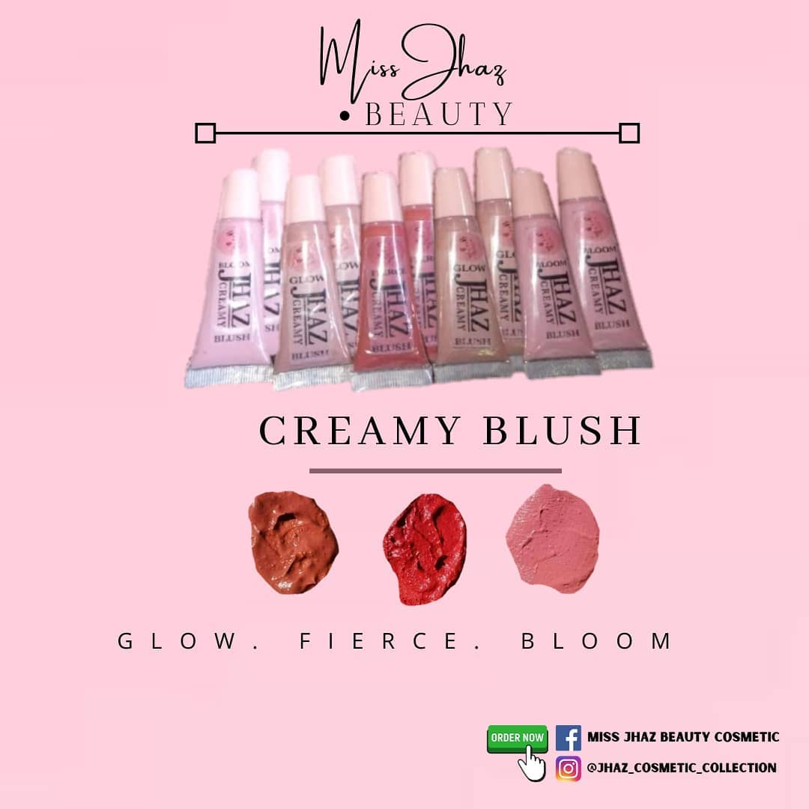

PRODUCT NAME: Creamy Blush

PRICE: 100 Php

DESCRIPTION:

Available shades:

* Fierce
* Bloom
* Glam

Jhaz Creamy Blush blends like silk and melts into skin like a cream but has the highly pigmented, long-wearing perks of a powder. This light-as-air cream blush has a fluffy, whipped texture that melts right into your skin as soon as you dab it on. Just use your fingers to tap it on your cheeks for a subtle, lit-from-within glow.

Tips: While powder blushes are easy to apply, they are a big no-no for mature skin; they make your skin look more wrinkled and aged. Cream blushes do the exact opposite – they work well on dry skin, as most of them are made with natural and hydrating ingredients.

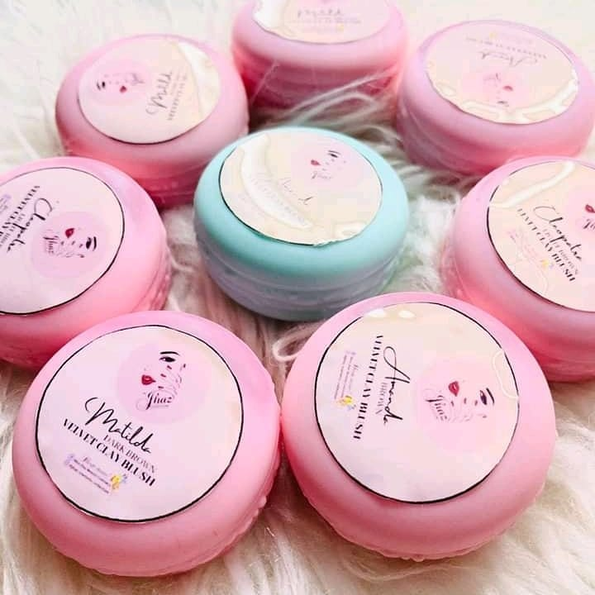

PRODUCT NAME: Velvet Clay Blush

PRICE: 100 Php

DESCRIPTION:

Shades:

* Brown
* Light brown
* Dark brown

Every girl wants to have that natural-looking tinted cheeks that gives out a stunning radiance. Miss Jhaz Organic Clay Blush can give you this and more. It's lightweight, non-greasy, and very easy to blend. But, with so many fake products around, the best thing you can do is to be conscious and cautious at all times. Achieve a natural flushed look with #MJBC Clay Blush. Can use for your cheek, lips and eyeshadow.

All vegan ingredients

• Very pigmented

• Long lasting

• FDA Approved!

• Easy to apply, no grease

• Proven safe!

• 100% organic. Don't panic it's organic.

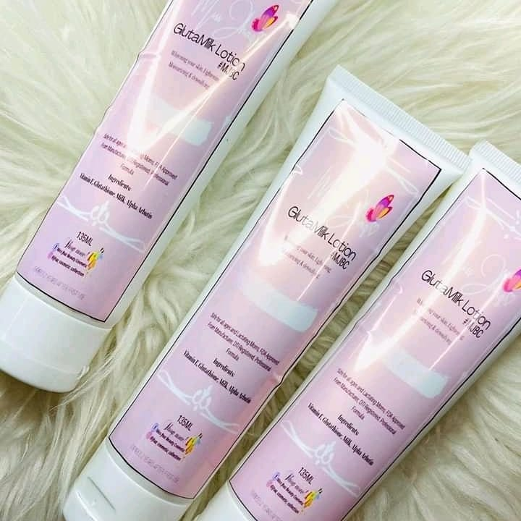

PRODUCT NAME: Gluta Milk Lotion

PRICE: 110 Php

DESCRIPTION:

Nearly all black and brown skin are beautiful but a beautiful white skin is rare. Miss Jhaz GLUTA Milky Lotion super speed extra whitening and UV protect body lotion with 10x glutathione and 10x pure milk concentrated for whitening your skin with FDA APPROVED.